Online Registration Instructions

Make sure your course request sheet is completely filled out. You will be using it for reference during the online process.

- Log on to StudentVue
- Select “Course Request”
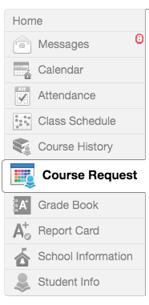

- Select “Click here to change course requests”
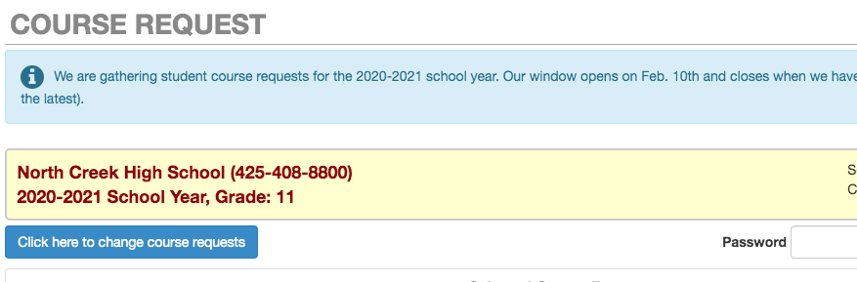

- Now it’s time to start adding the classes you have already picked on your Course Request Sheet.
- It is very important that you ONLY SEARCH BY COURSE CODE. Course codes for every class you add are on the Course Request Sheet. Use those codes!

- In the Course ID box, add your first Course Code in the search box below Course ID.
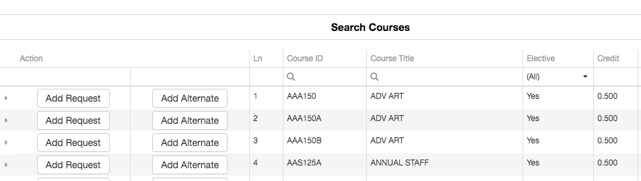

- You will be able to tell if you have already taken the class or if you are currently enrolled in the class.
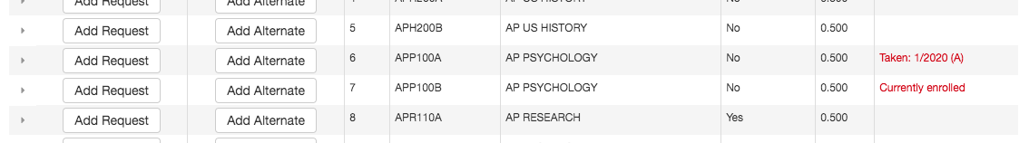

- Once the Course Code is typed in, the course with title will be listed below. If it is the course you want, select “Add Request.” Note: If it is a semester class, there will be only 1 line.
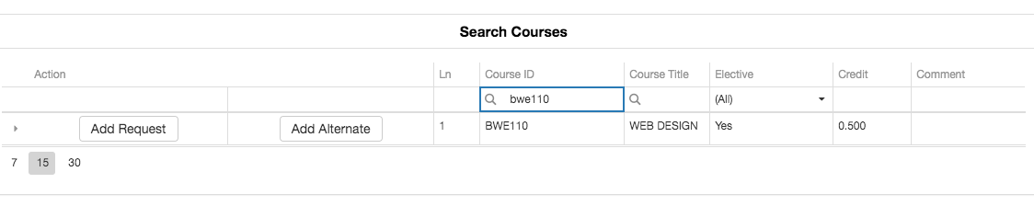

- If the course is a full year course, it will have 2 lines. YOU NEED TO SELECT “Add Request” FOR BOTH LINES FOR YEAR-LONG COURSES.
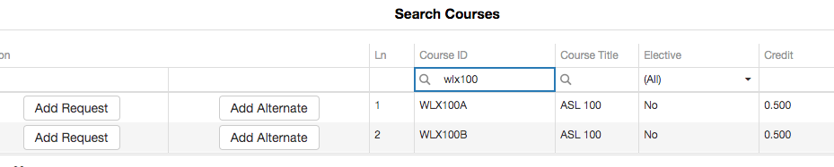

- Once you have selected “Add Course,” the course will appear in the “Selected Course Requests” area. Make sure you add all of your requests. Your total should say 7.
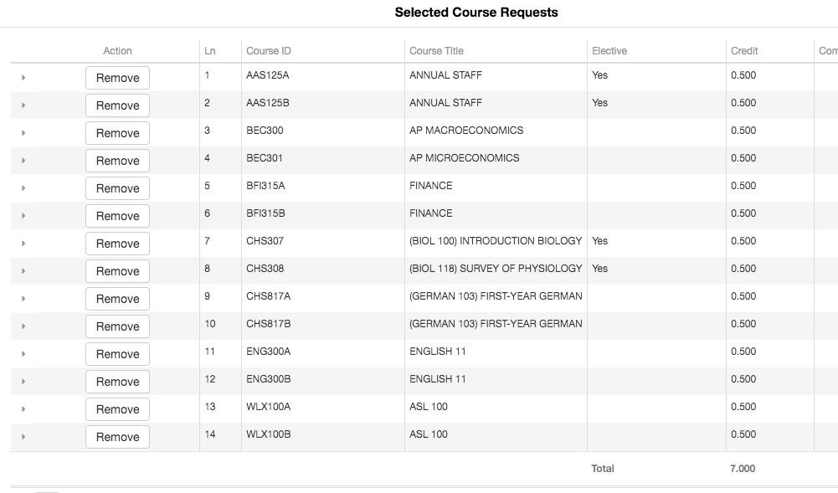

- Now it is time to add your alternates. It is important to add several. These are the classes we will refer to if your 1st choice class isn’t available. Use the same process for adding requests but instead select “Add Alternate”

- You should have a combination of semester classes and year-long classes. And remember to pick several!
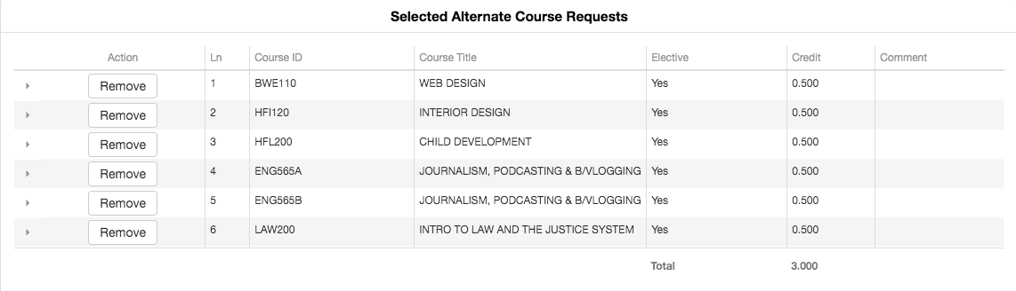

- You are done! YOU DO NOT NEED TO WORRY ABOUT LOCKING YOUR SELECTIONS. Your selections will be “locked in” during your pick-up day. You can make changes to your selections until your pick-up day. Make sure your StudentVue entries match your signed paper registration packet.

PICK UP DAY SCHEDULE: MAKE SURE YOUR CLASS SELECTIONS HAVE BEEN ENTERED INTO STUDENTVUE AND BRING YOUR COMPLETED AND SIGNED.

NCHS
- Current 9th March 10th
- Current 10th March 10th
- Current 11th March 6th

Jr. High
- Skyview - March 4th
- Leota - March 4th
- Canyon Park - March 5th
- Northshore - March 5th
- Timbercrest - March 5th

REMINDER: Assistance with how to proceed with course requests can be found on the NCHS website under the counseling tab. Select Course registration.

