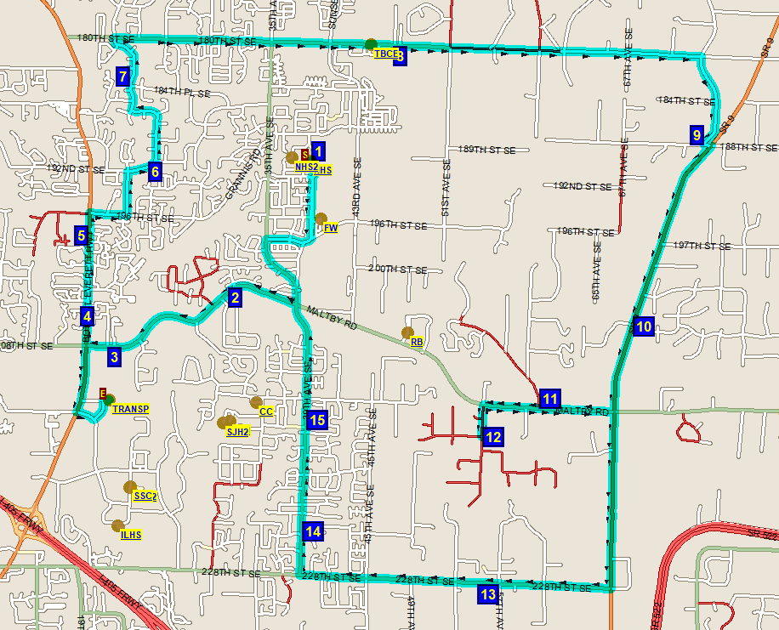**North Creek High School - Activity Map**

Little Bear Creekview

Start: NCHS

Chestnut trails Redhawk

Willow Tree Apts

180th ST SE @ 46th DR SE

22nd DR SE @ 184th PL SE

Temple

Sutherland Park

228th ST SE @ 57th AVE

Malty Rd @ 55th Ave SE

Lincoln Shireview

Clearviewview

Avalon

Autumn Chase

Waterstone